Android App Project Outline

1. Project Description
   1. This app is an ad-on to navigation apps such as Google Maps or Waze. Allowing users to view real time parking information that will guide them to both street level parking and parking lots that have open availability.
   2. Additionally, the app will also provide a payment mechanism to streamline payment and parking authorization.
2. Problem Addressing
   1. This app is being developed in order to provide drivers in urban areas access to real time parking information in an effort to alleviate congestion, time searching for parking, and frustration.
3. Platform
   1. The app is being developed for use on the most recent Android operating system with rollout of the iOS platform.
4. Front/Back end support
   1. Front end support relies heavily on HTML code to allow visual cues to overlay on top of navigational data.
   2. Backend support relies on servers and databases that feed the app need information to provide the user with real time parking information.
5. Functionality
   1. Conceptually this app will function as a layer on apps like Apple or Google maps as well as navigation apps like Waze. These navigation apps already get you to your destination but leave out a keep aspect of where to park when you get there. If the app can suggest parking options based on destination it can alleviate the need to circle your destination multiple times looking for a decent place to park.
6. Design (wireframes)
   1. As a layer on one of the several navigational apps this app will not require a full standalone design.
   2. 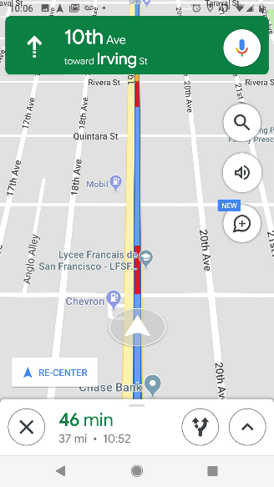The app will be a layer selectable at the time of inputting destination information and will appear similar to this example.

